

Worksheet 6

Student Name: Ramesh Kumar UID:25MCI10304
Branch: MCA (AI & ML) Section/Group: 25MAM-5A
Semester: 1st Date of Performance:27-10-2025 Subject Name:Design and analysis of algorithms Subject Code: 25CAP-612

Aim/Overview of the practical:

To design and implement an algorithm to find a subset of a given set S = {5, 7, 9, 11, 13} of positive integers whose sum is equal to a given positive integer d = 20 using the Backtracking technique.

2. Task to be done:
- Start the program.
- Input a set of positive integers and a target sum $d$.
- Create a recursive function to generate all possible subsets of the given set.
- Add elements one by one to the current subset.
- Calculate the sum of the subset elements at each recursive step.
- If the sum equals the target value $d$, display that subset.
- If no subset equals the desired sum after checking all combinations, display “No subset found with the given sum.”

3.Algorithm:

Step 1: Start.
Step 2: Initialize the given set $S=\{5,7,9,11,13\}$and the target sum $d=20$.
Step 3: Define a recursive function subset_sum(S, target, current, index) that:
Step 4: Include the current element S[index] in the subset and call recursively with target - S[index].
Step 5: Exclude the current element and call recursively with the same target.
Step 6: Repeat Steps 4 and 5 until all elements are checked.
Step 7: If no valid subset found, print “No subset found with the given sum.”
Step 8: Stop.

4.Code:

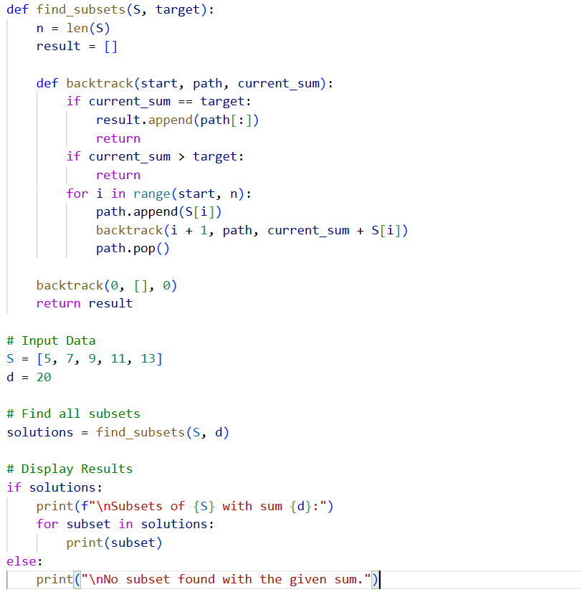

5.Output:
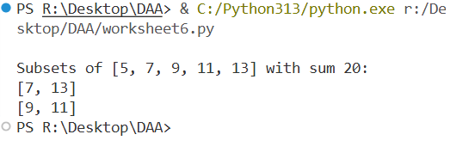

6.Learning Outcomes: -

- Understood the working of Backtracking in solving recursive problems.
- Learned to generate all possible subsets of a given set using recursion.
- Gained experience in using base cases to stop recursion efficiently.
- Developed logic for checking sum conditions dynamically.
- Learned how to display multiple possible solutions for a problem.
- Understood how to handle no-solution cases gracefully in programs.
- Strengthened knowledge of recursive problem-solving and combinatorial logic in Python.

